MEDICAL INVENTORY MANAGEMENT

## College Name: Sree NarayanaGuruCollege College Code: bru36



**Team ID: NM2025TMID26514**

**TEAM MEMBERS:**

Team leader: vishnu M [Email:vishnujithu9746@gmail.com](mailto:vishnujithu9746@gmail.com)

Team Member:Vincy. S [Email:vincyvincy557@gmail.com](mailto:vincyvincy557@gmail.com)

Team Member:Yahya mohammed. M

[Email:Iamyahyamohammed@gmail.com](mailto:Iamyahyamohammed@gmail.com) Team Member:sreekuty.s

[EmailSreekuttyammu293@gmail.com](mailto:EmailSreekuttyammu293@gmail.com)

## 1.2 Purpose

Thepurpose of this project is to design and implement a Salesforce-based Medical Inventory Management System that ensures efficient tracking, management, and monitoring of medicines, medical supplies, and related transactions within healthcare organizations such as hospitals, pharmacies, and clinics.

# Development Phase

**Creating a developer account** : We can create an developers account in salesforce by using the following url

**URL:-** [**https://www.salesforce.com/form/developer-signup/?d=pb**](https://www.salesforce.com/form/developer-signup/?d=pb)

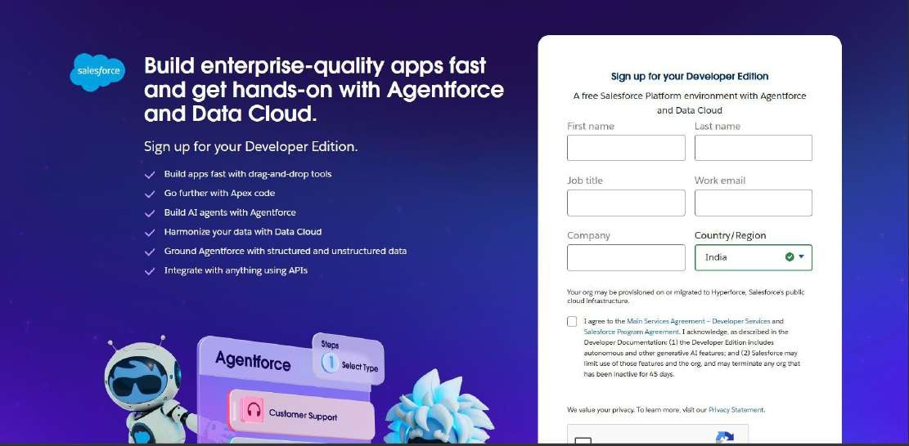

**Creating objects:-** We created object named Products , Purchase Order, Order Item, Inventory Transaction and Supplier.

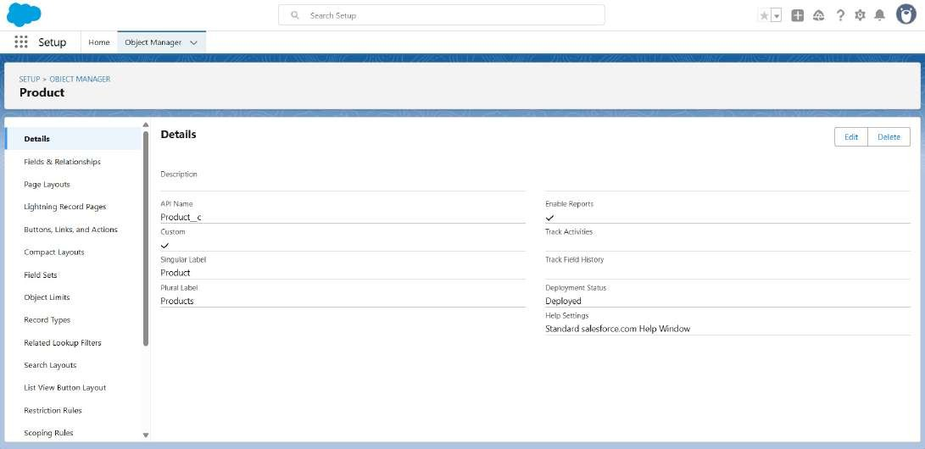

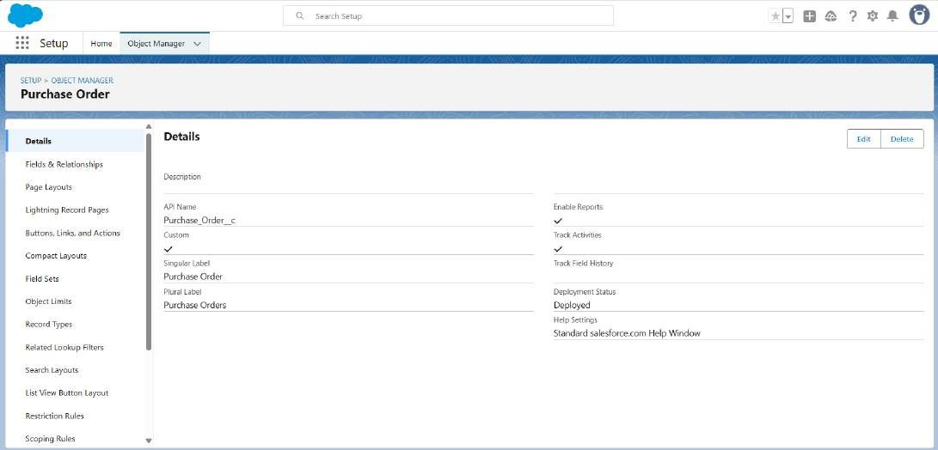

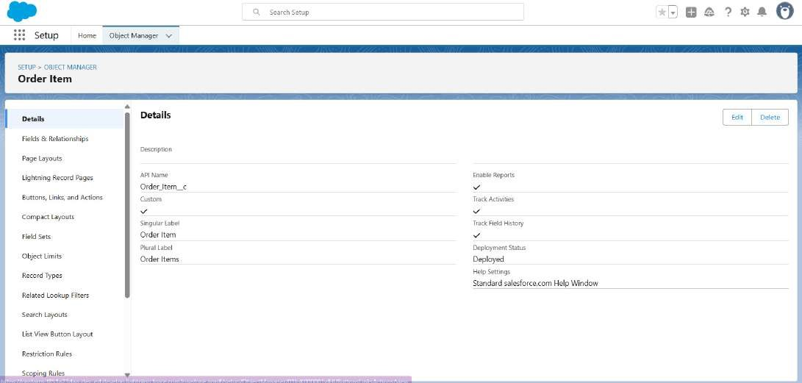

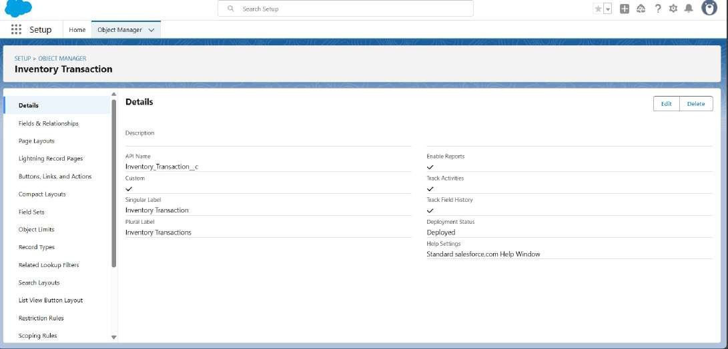

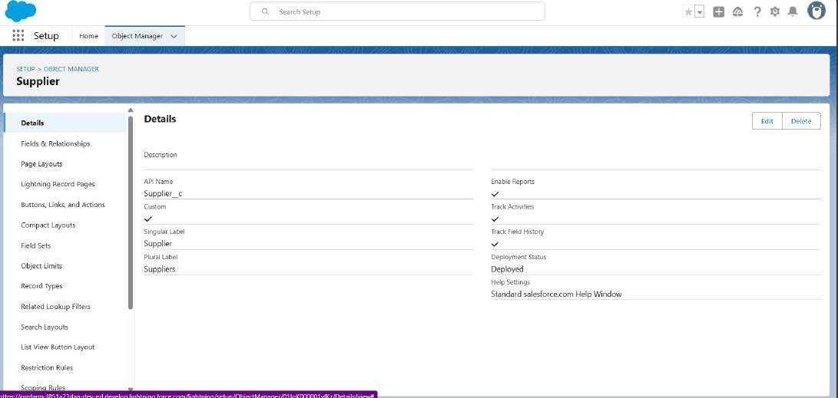

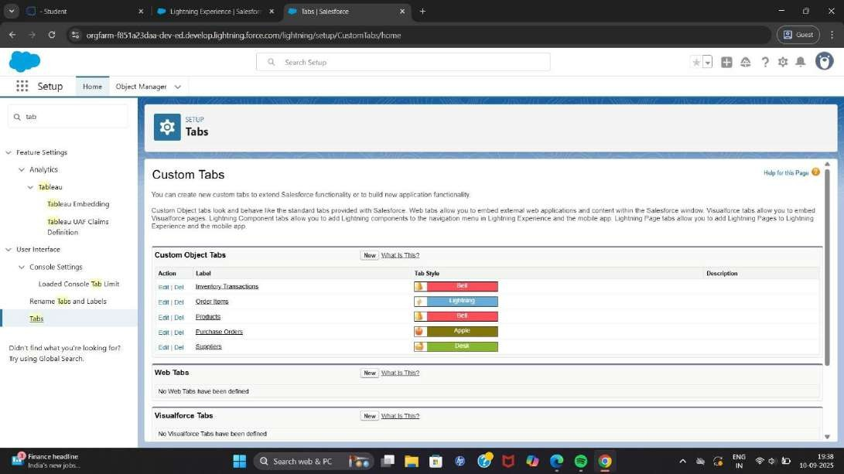**Creating Tabs :-** We have created the tabs for the custom made objects Products , Purchase Order, Order Item, Inventory Transaction and Supplier.

**Creating the Lightning app :-** We created an lightning app named Medical Inventory Management with items Products, Purchase Orders, Order Items,

Inventory Transactions, Suppliers, Reports, and Dashboards and Profiles with System Administrator.

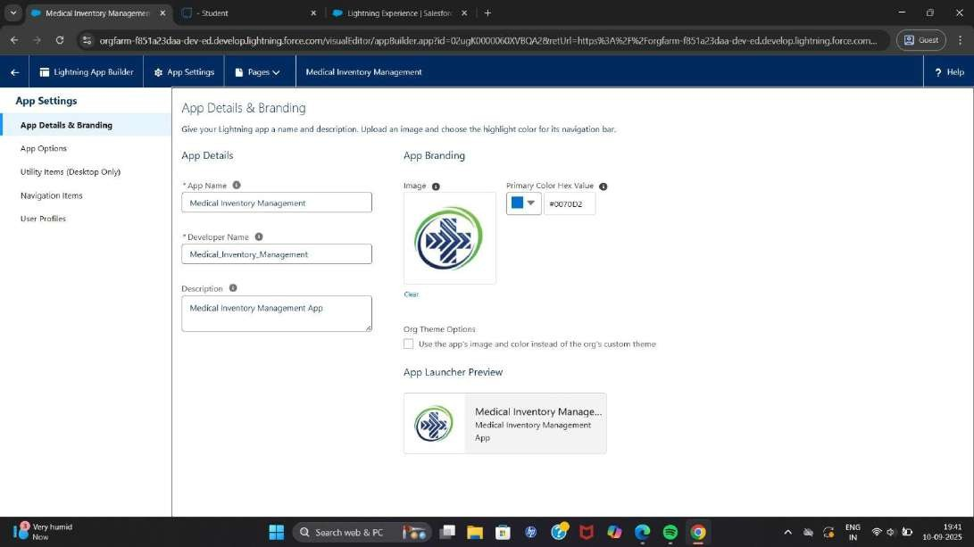

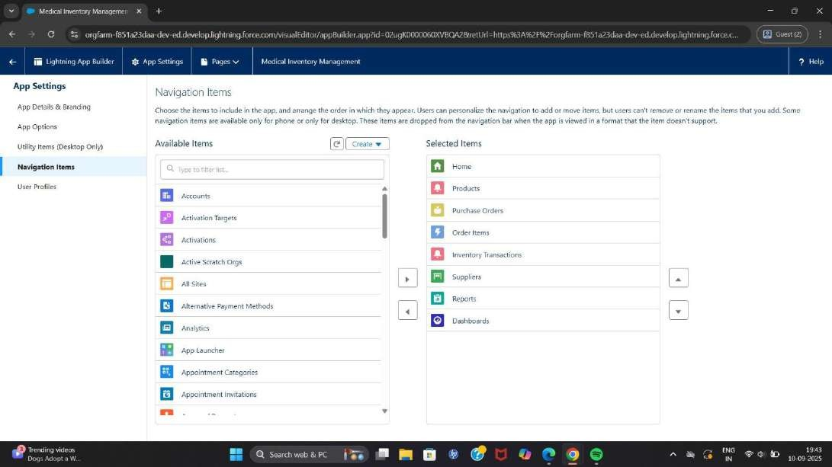

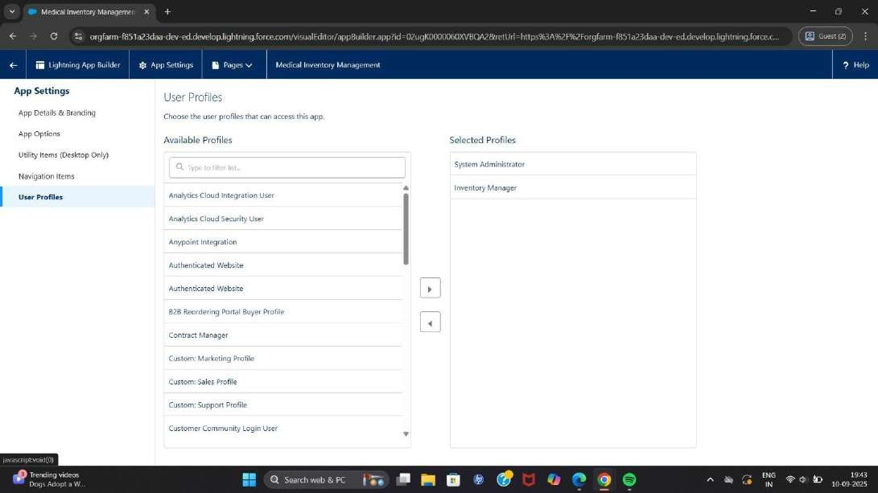

**Configuring Fields and Relationship :-** We created various fields and relationship for each custom objects.

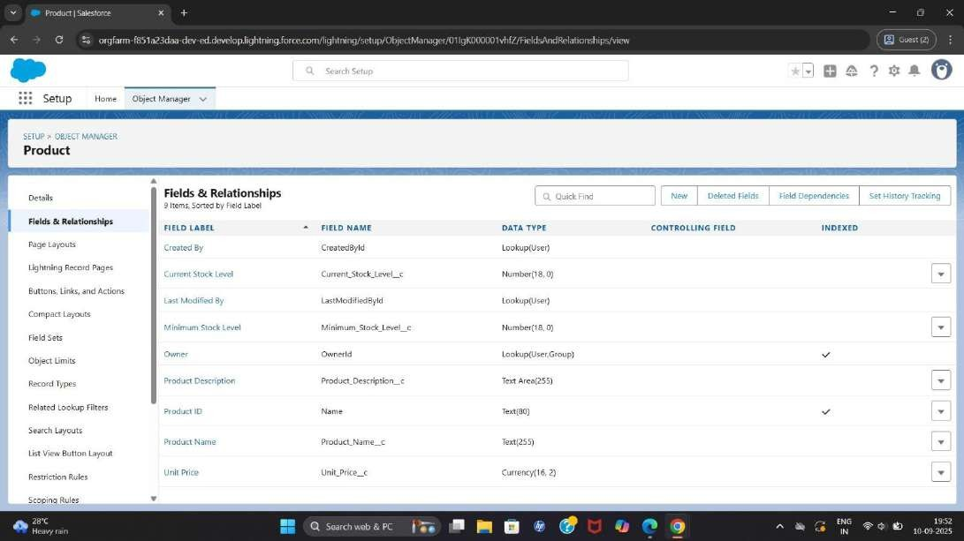

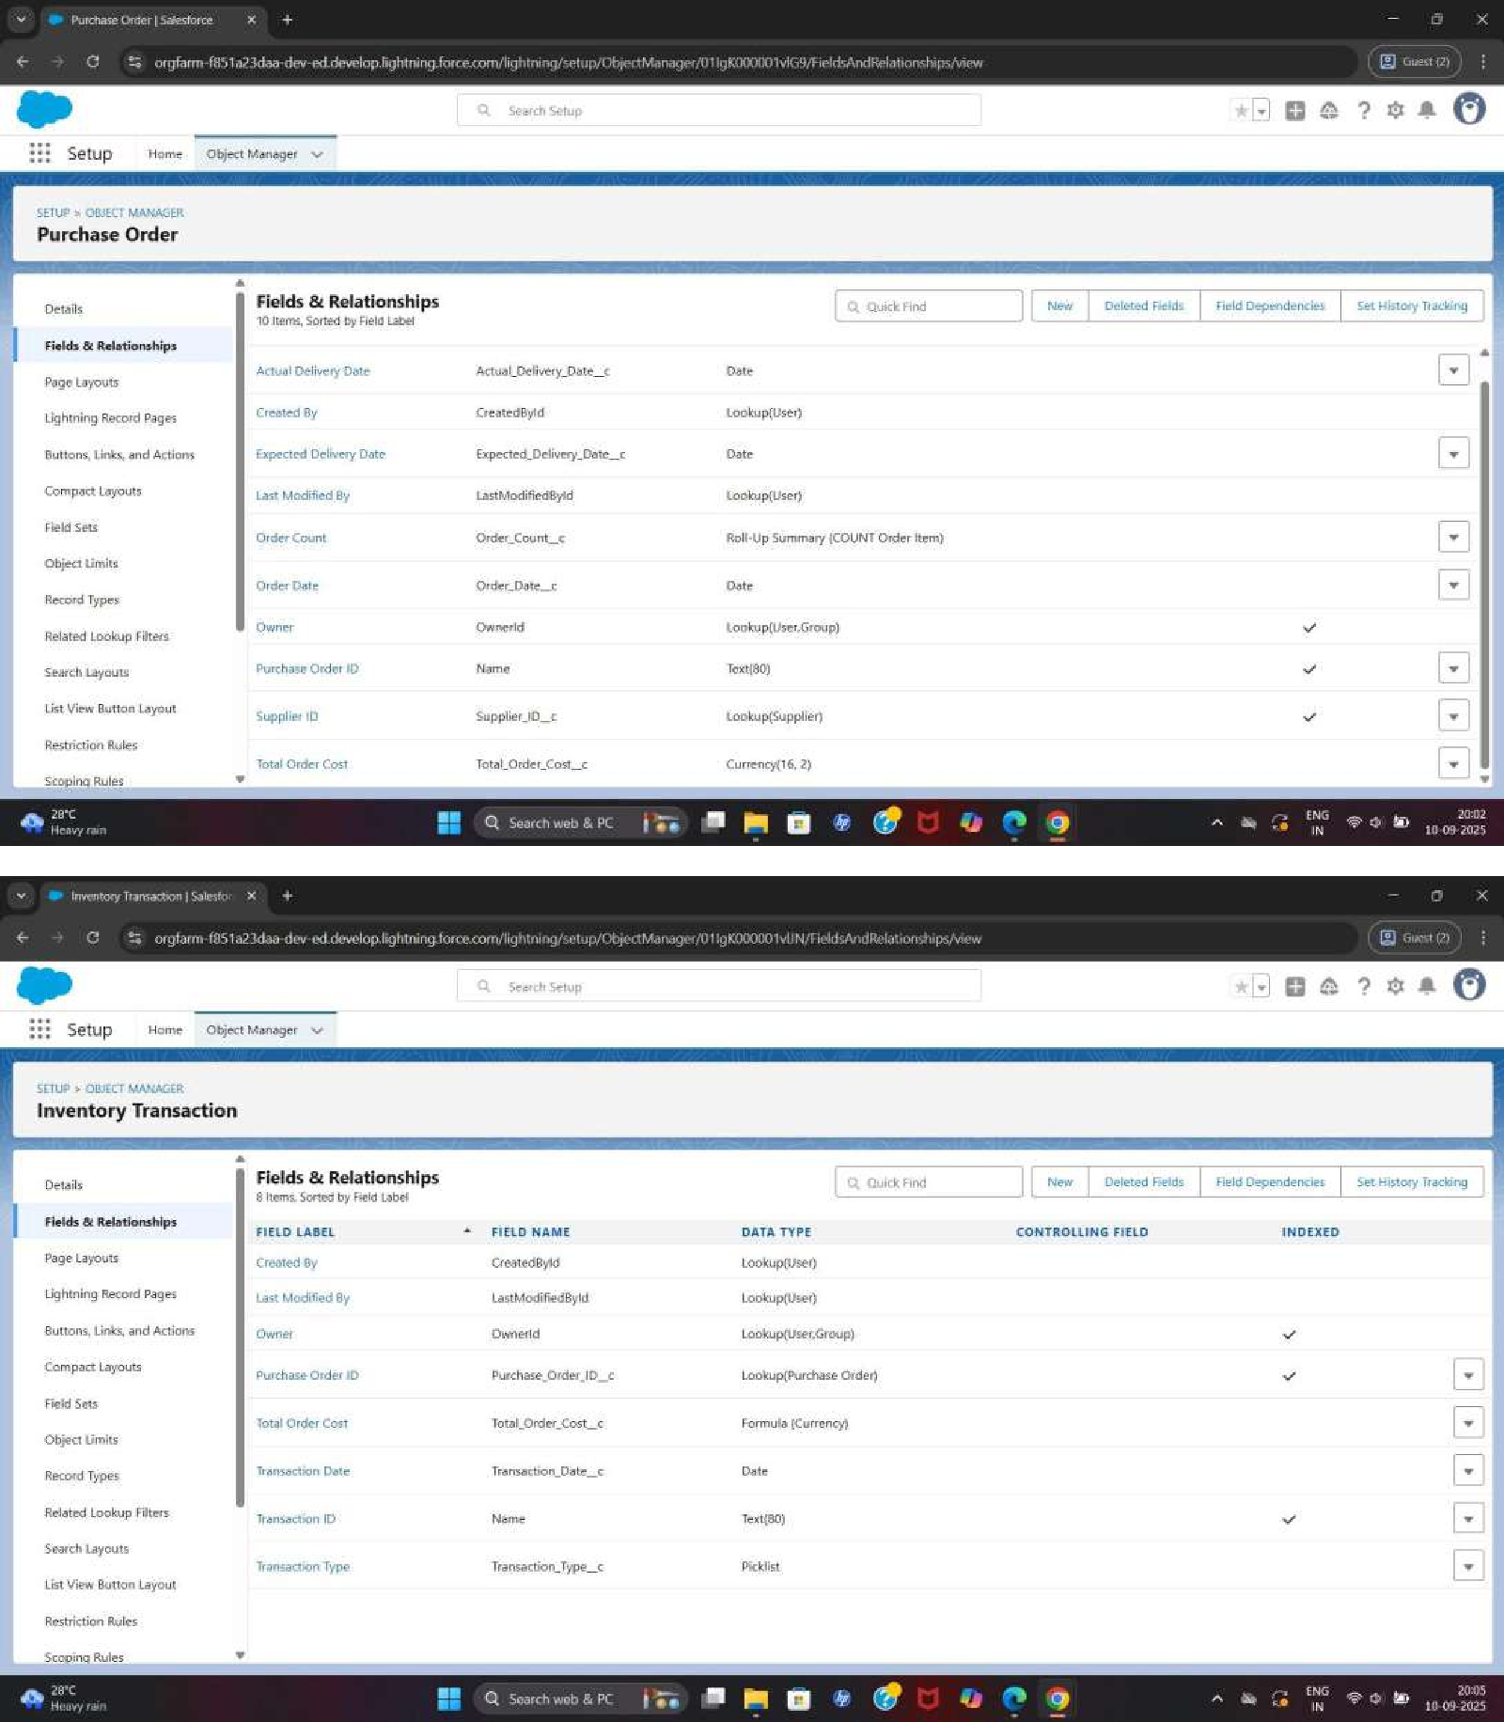

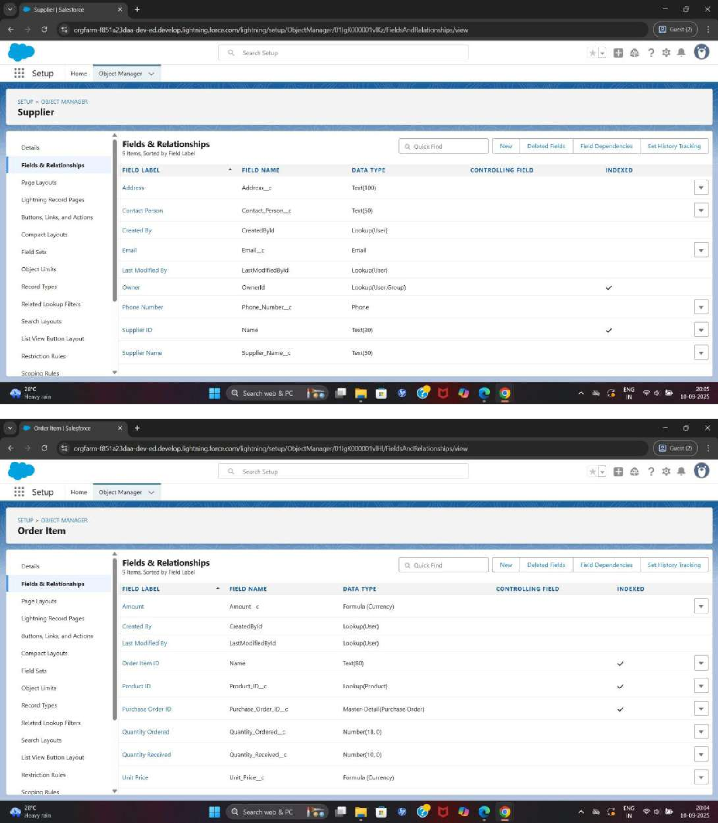

**Setup of the Page Layout:-** We edited the Page Layout for the custom objects.

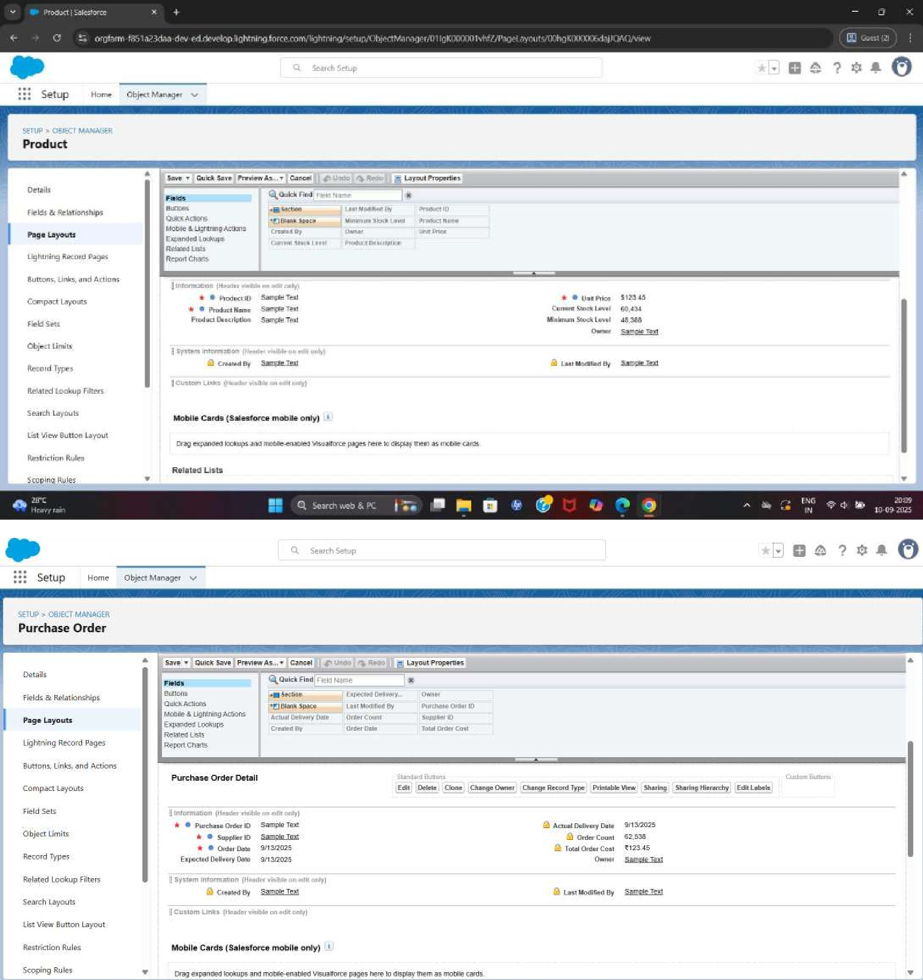

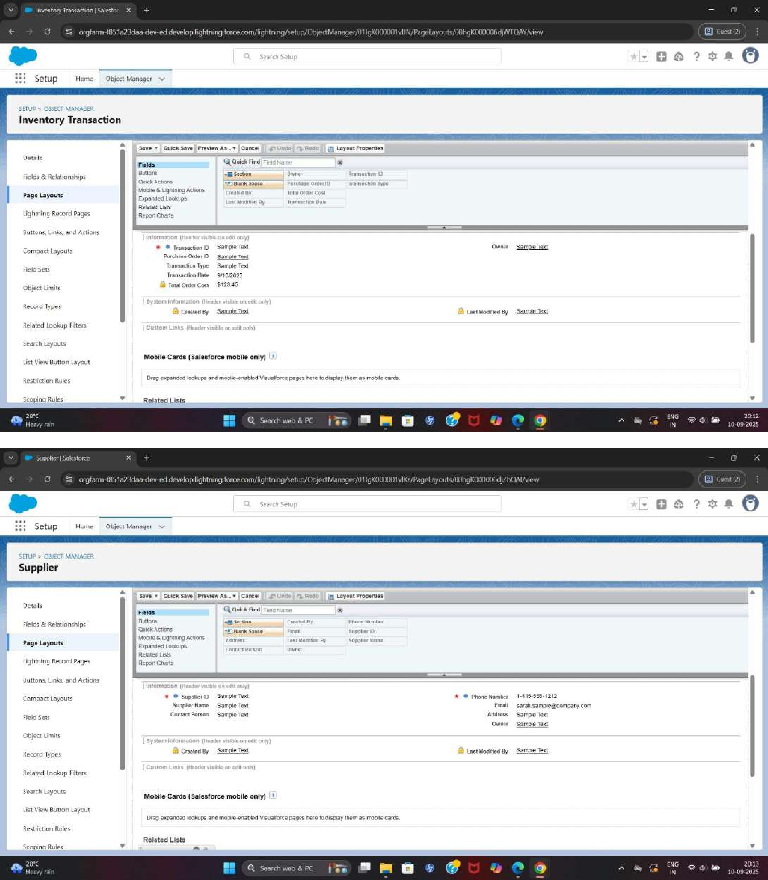

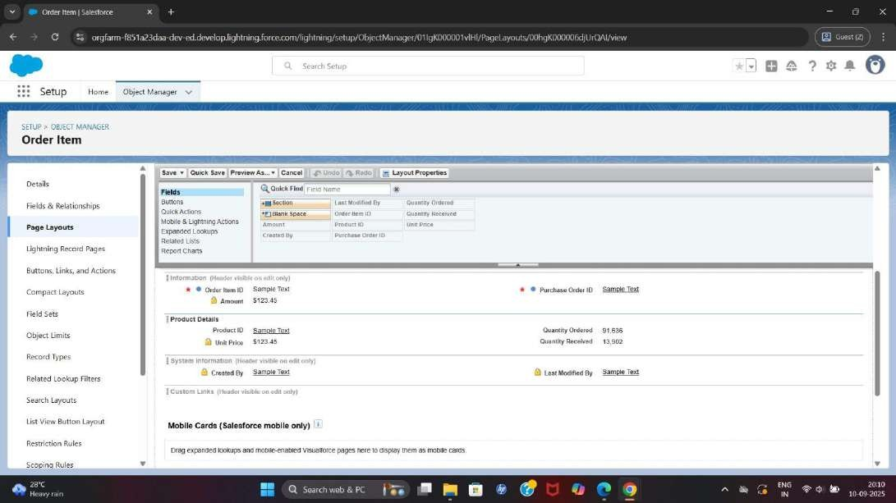

**Compact Layout:-**We created Compact Layout for the Custom object Product and Purchase Order.

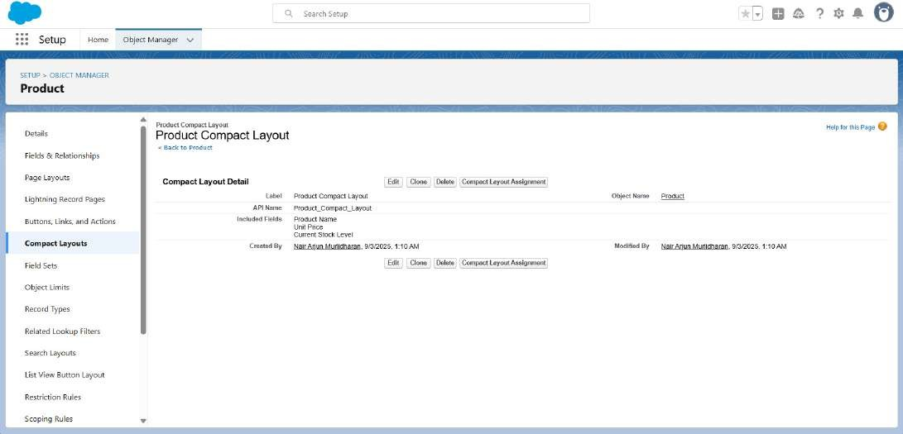

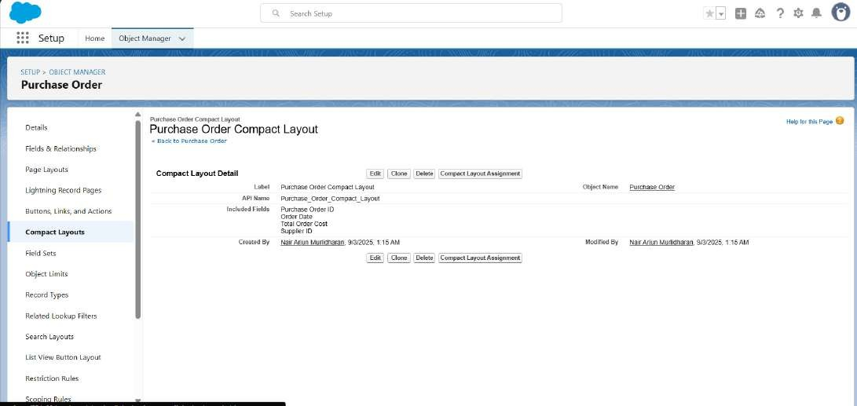

**Validation Rule:-** We created an validation rule under Purchase order for expected delivery date.

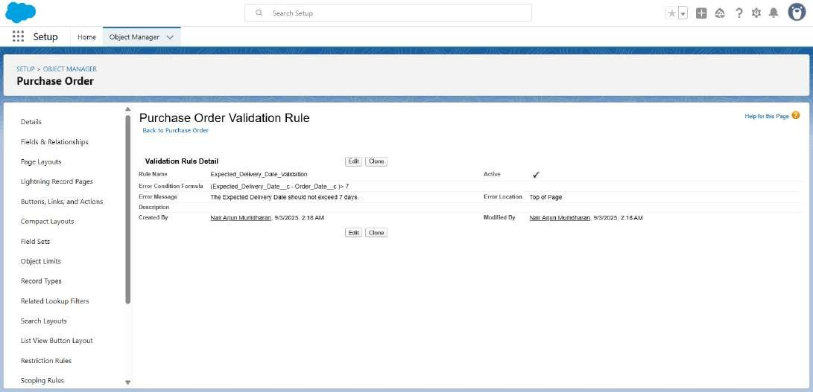

**Profiles:-** We created Profiles named Inventory Manager and Purchase

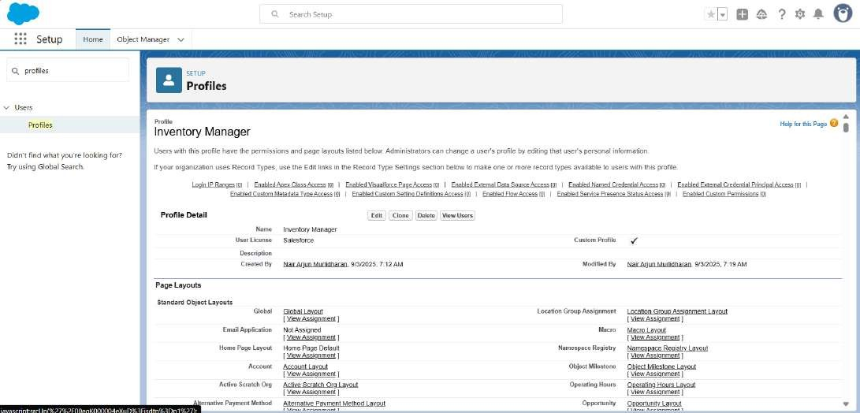

Manager.

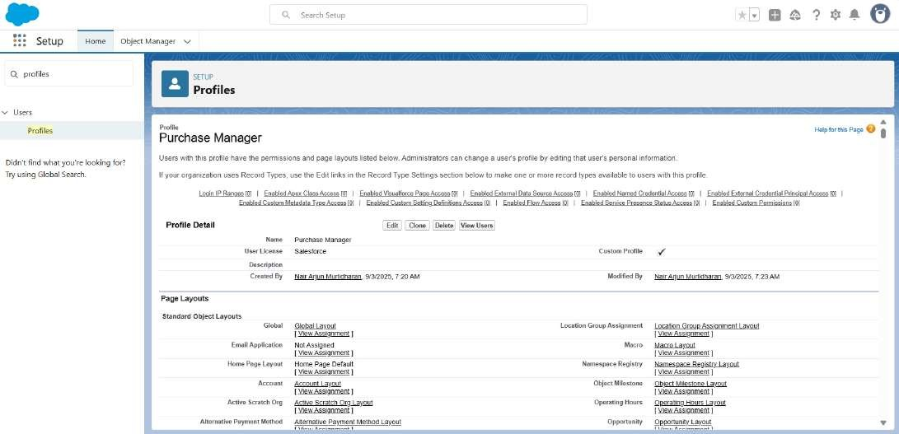

**Roles:-** We created an Roles of Inventory Management and Purchasing Management.

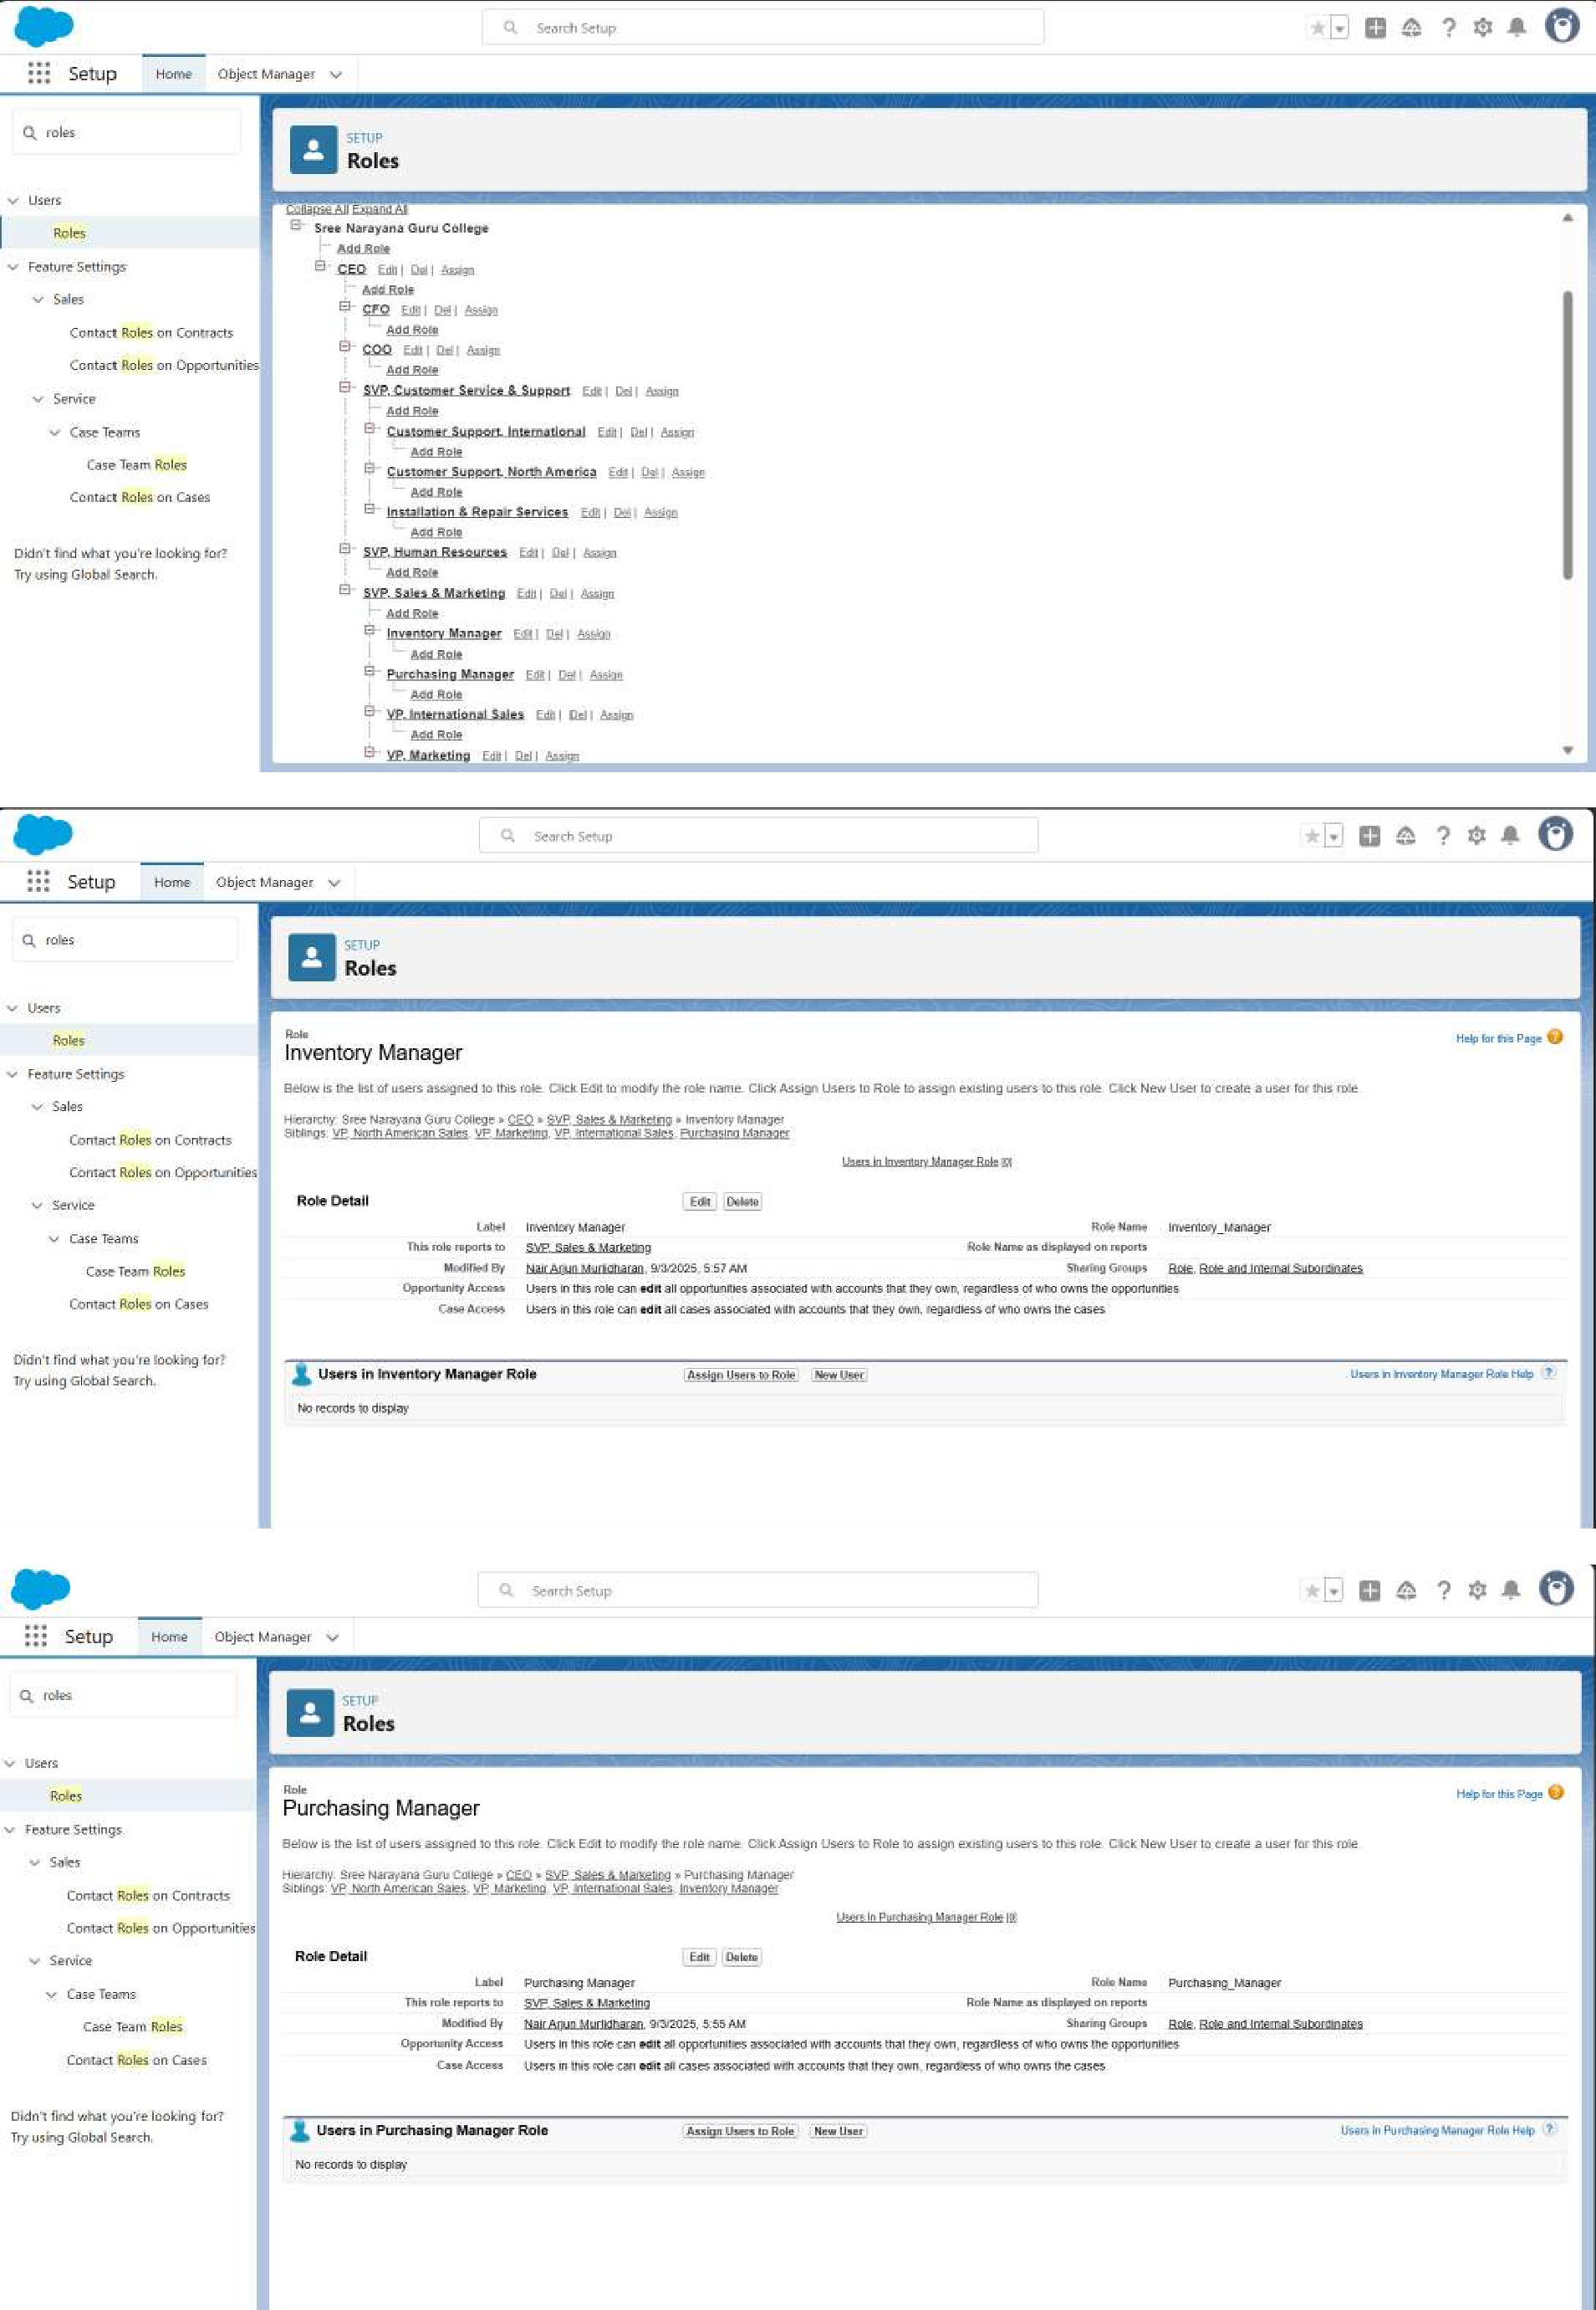

**Permission Sets:-** We created Permission set for the Medical Inventory

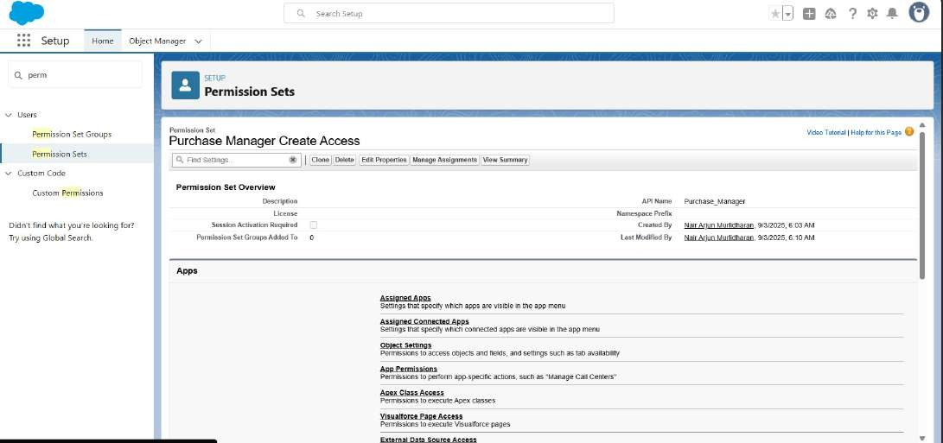

**Flows:-**We created flow named Actual Delivery Date Update to update the actual delivery date.

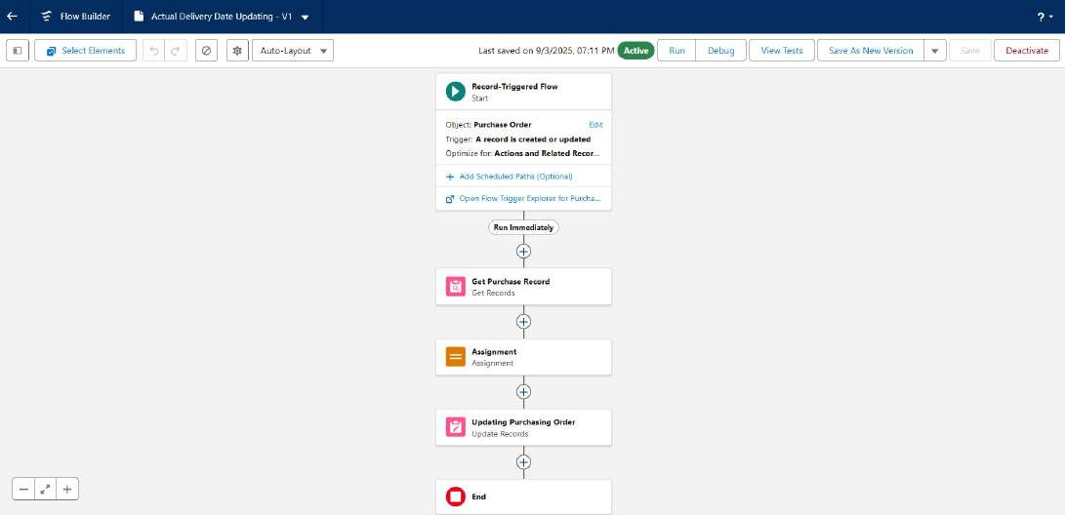

**Apex Triggers:-** We created the trigger to calculate the Total amount on Order item.

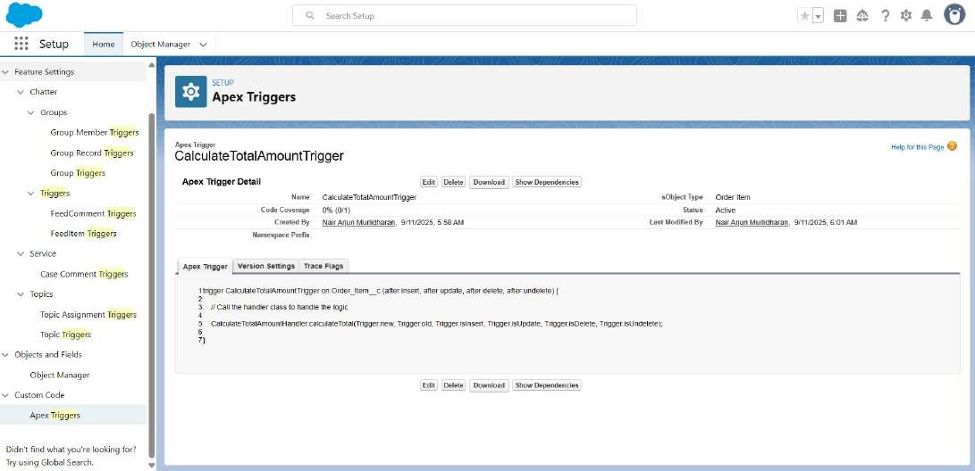

**Apex Classes:-** We created Apex Handler class.

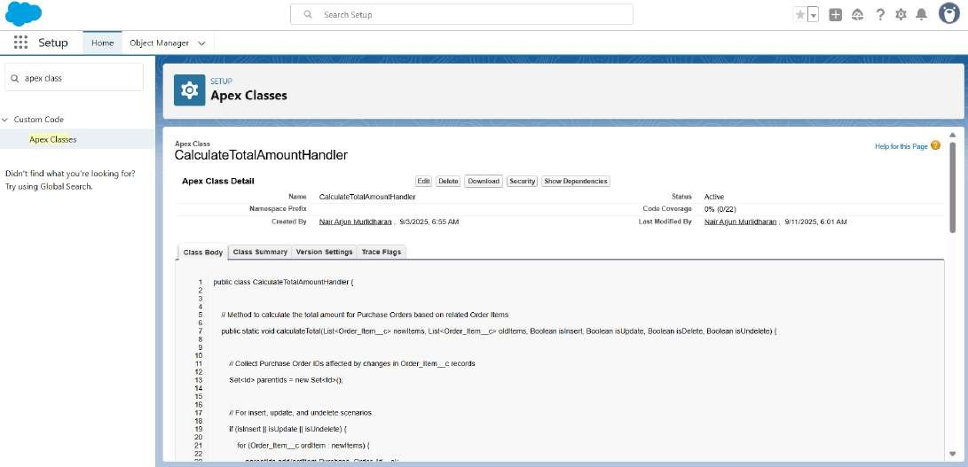

**Reports:-** Creating Reports named Purchase Orders Click Start report and Complete Purchase Details Report.

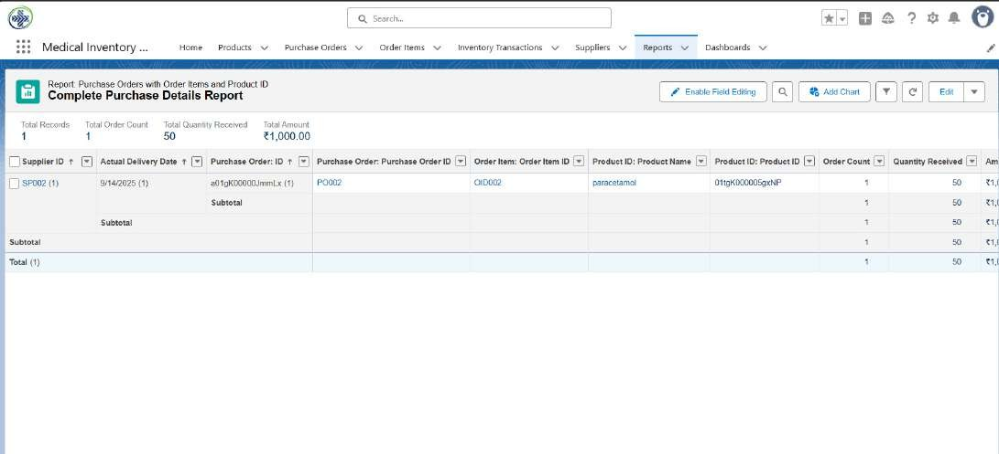

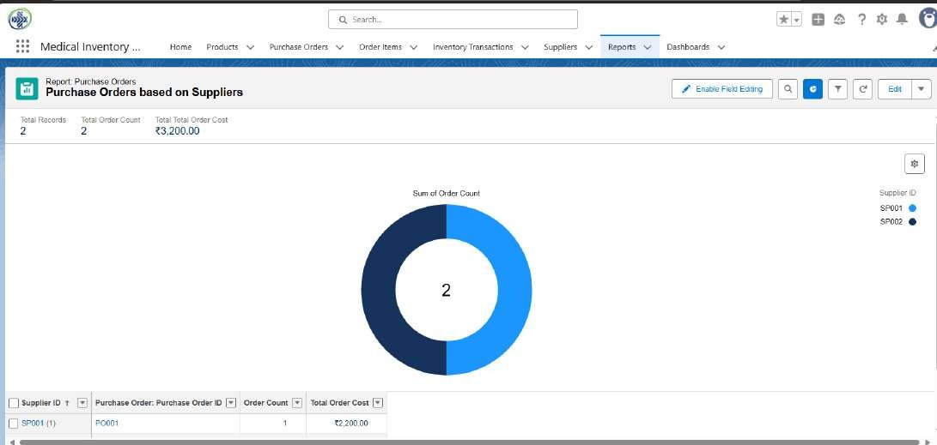

**Dashboards:-** We created the Dashboard for the Medical Inventory Management.

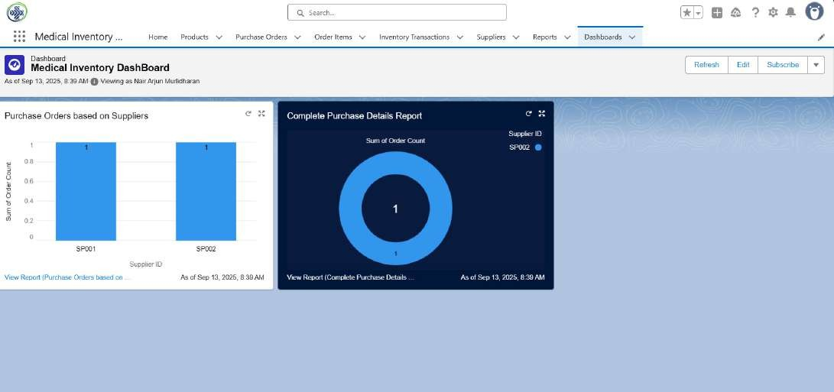

# FUNCTIONAL AND PERFORMANCE TESTING

## Performance Testing

Testing the Triggers to get the total amount in the Order Item

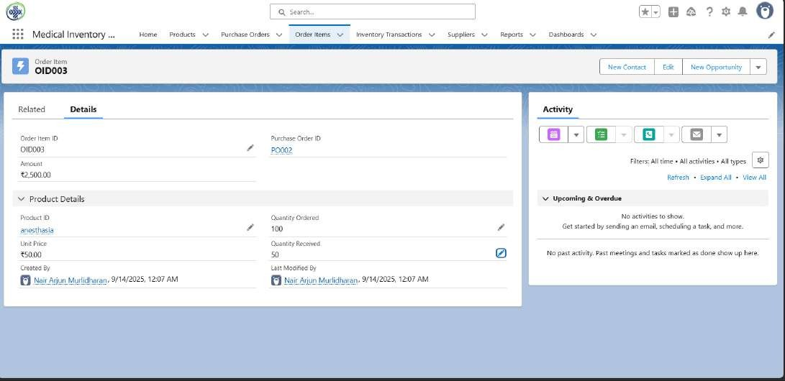

Validation Rule checking

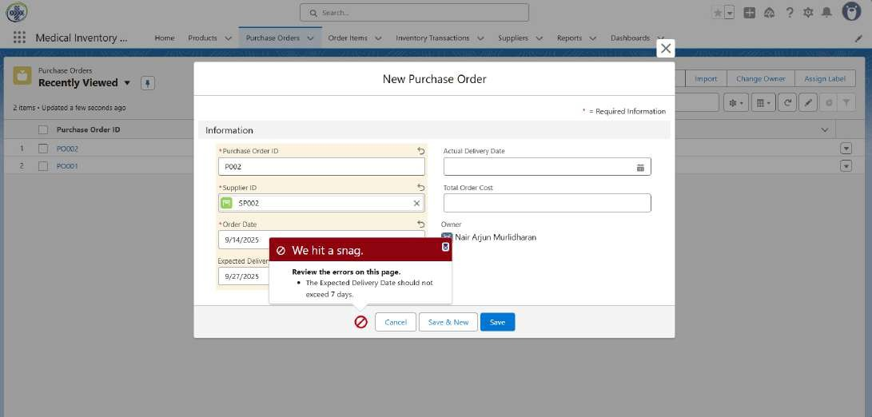

# RESULTS:-

**Home page**

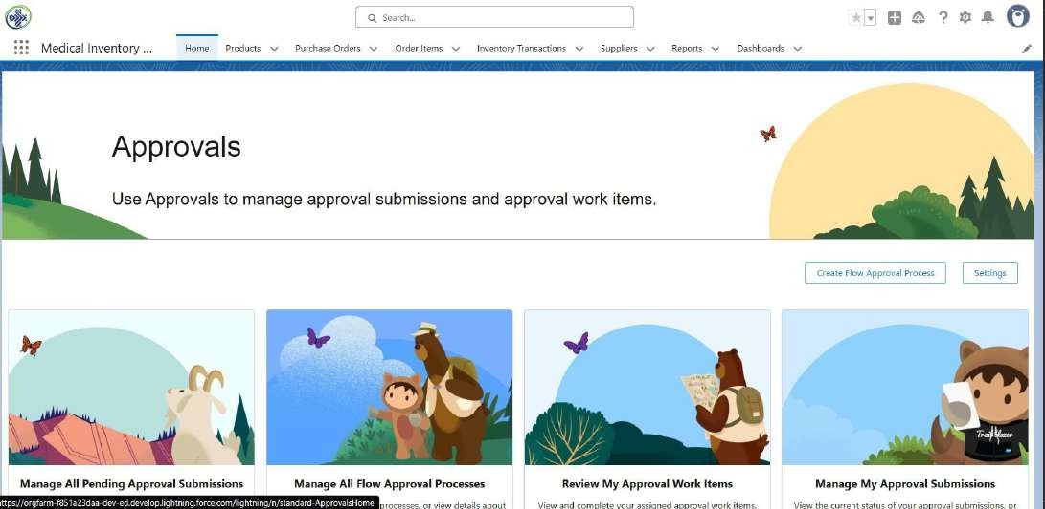

**Products Page**

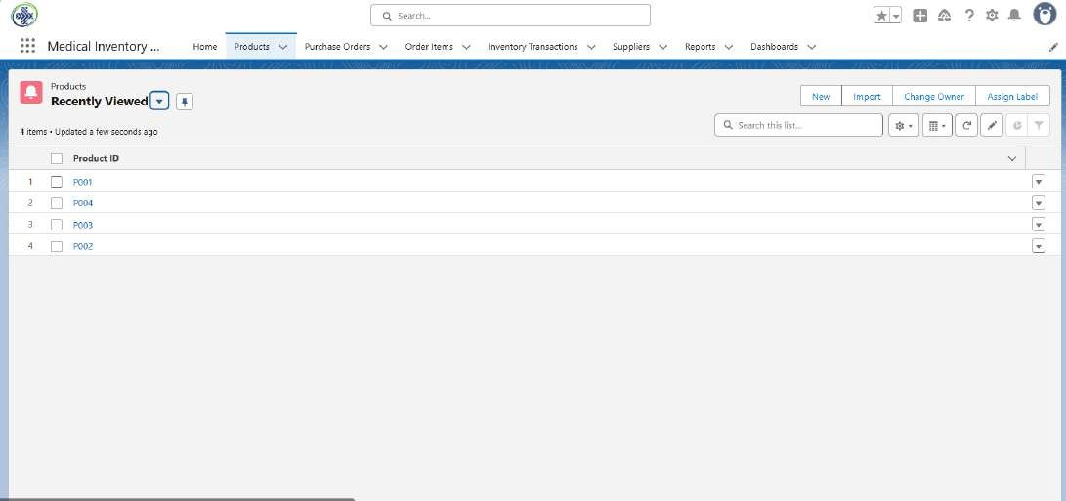

**Purchase Orders**

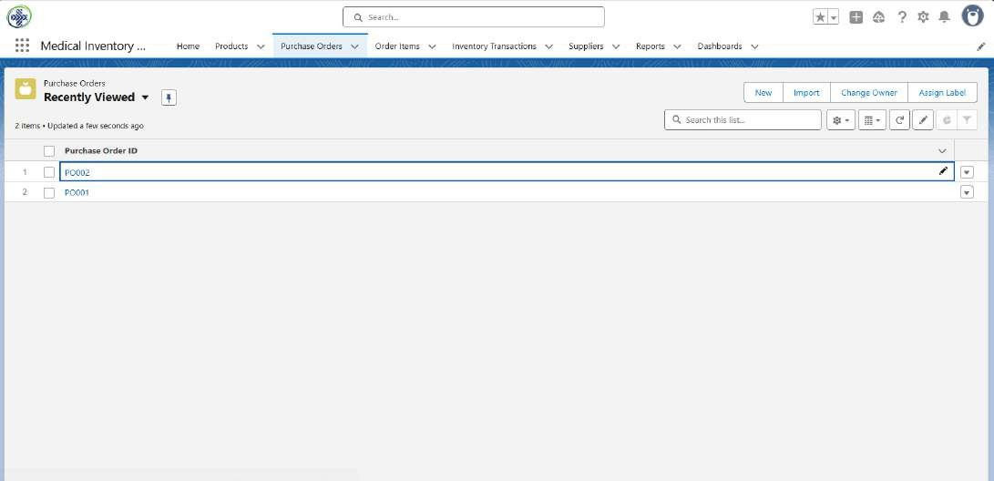

**Order items**

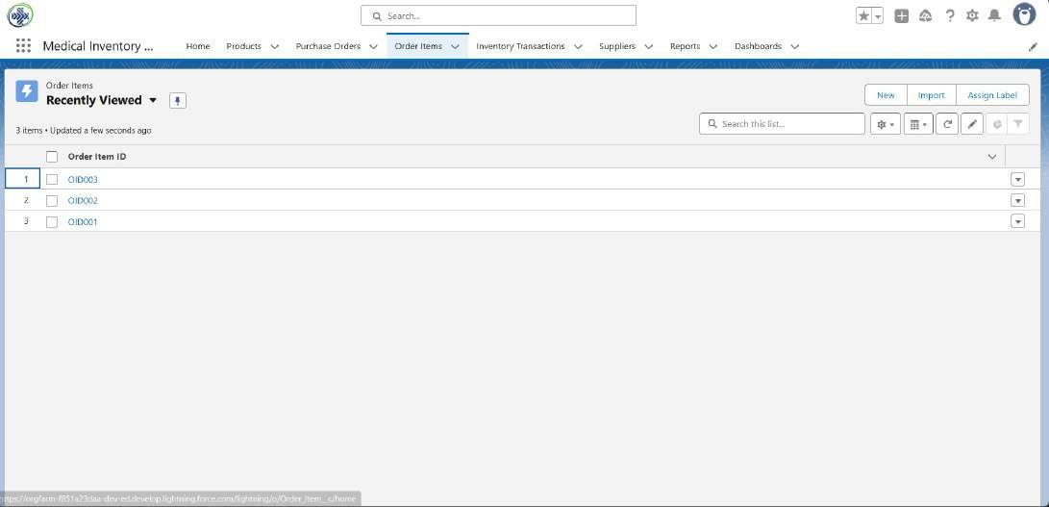

**Inventory Transactions**

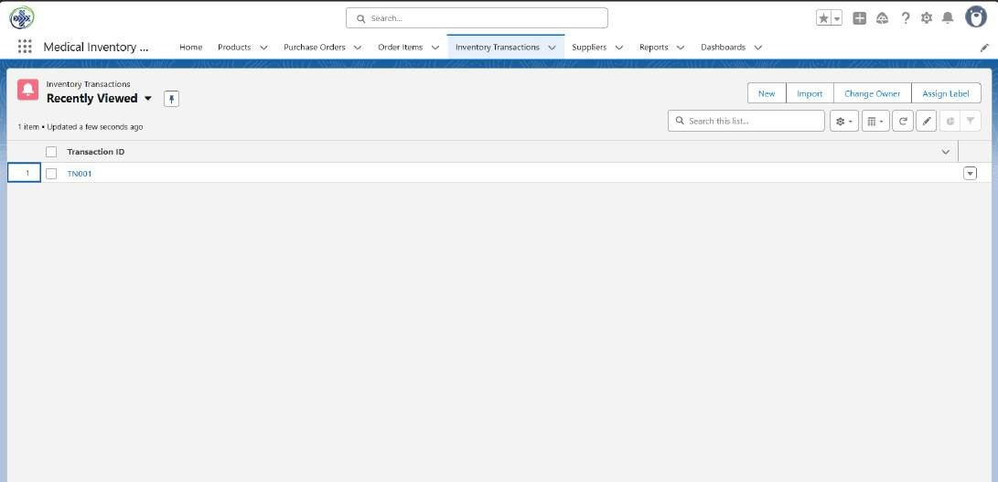

**Suppliers**

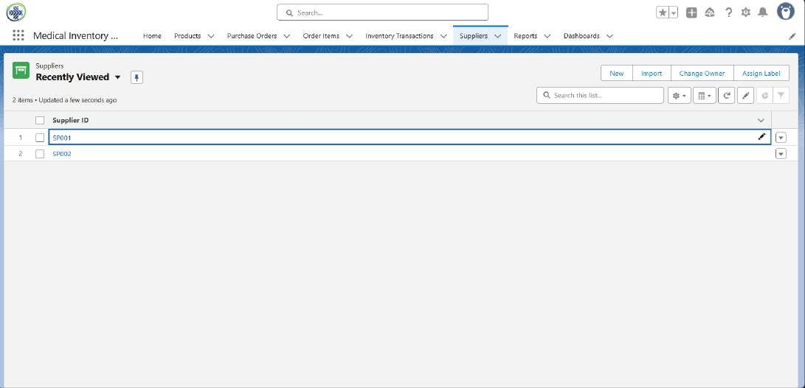

**Reports**

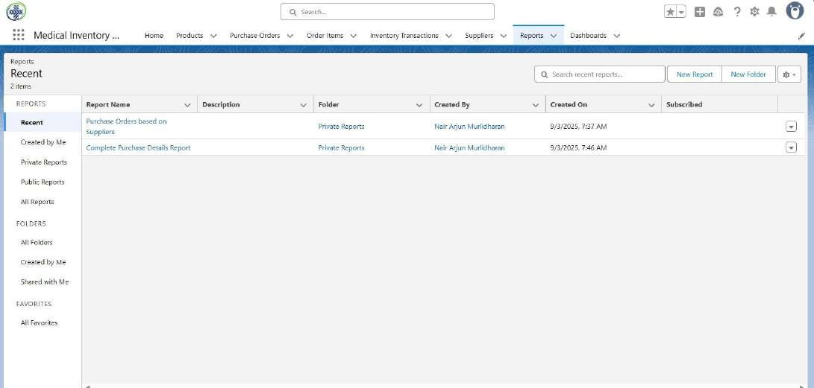

**Dashboards**

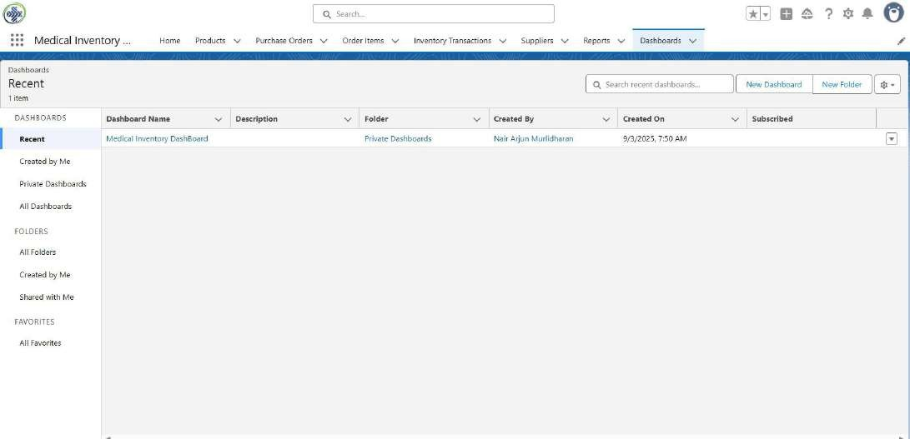

# ADVANTAGES AND DISADVANTAGES OF MEDICAL INVENTORY MANAGEMENT:- ADVANTAGES:-

1. **Centralized Data** – All medical inventory, supplier, and transaction

details are stored in Salesforce, easily accessible from anywhere.

1. **Real-time Tracking** – Automatic updates to stock after each transaction prevent stockouts and overstocking.
2. **Expiry & Low Stock Alerts** – Reduces wastage and ensures critical medicines are always available.
3. **Integration with Accounts** – Suppliers and customers are directly linked, improving accountability.
4. **Automation** – Formula fields, validation rules, and workflows reduce manual errors.
5. **Reports & Dashboards** – Provides clear insights into sales, purchases, and inventory status for better decision-making.
6. **Scalability** – Easily extendable to include new medicines, suppliers, or advanced automation.
7. **Cloud-based** – No hardware dependency, accessible anytime with Salesforce security features.

## DISADVANTAGES:-

**1In.itial Setup Complexity** – Customizing Salesforce objects, fields, and automation requires technical knowledge

**2D.ependency on Internet** – As Salesforce is cloud-based, it needs a reliable internet connection.

**3C.ost Factor** – Salesforce licensing and storage may be expensive for small clinics or pharmacies.

**4L.earning Curve** – Users need training to effectively use reports, dashboards, and automation.

**5C.ustomization Limits** – Some advanced features may require Apex coding or third-party apps.

# CONCLUSION

The Salesforce-based Medical Inventory Management System successfully demonstrates how CRM platforms can be customized beyond customer management to serve as a complete healthcare inventory solution. By integrating medicine management, transactions, suppliers, customers, and dashboards, the system ensures accuracy, efficiency, and reliability in handling medical stock. Despite minor challenges such as cost and setup complexity, the system provides long-term benefits including real-time monitoring, reduced wastage,

improved supplier relations, and data-driven insights. Overall, this project proves the effectiveness of Salesforce as a scalable platform for building critical inventory solutions in the medical domain.